2026 Prep Booklist
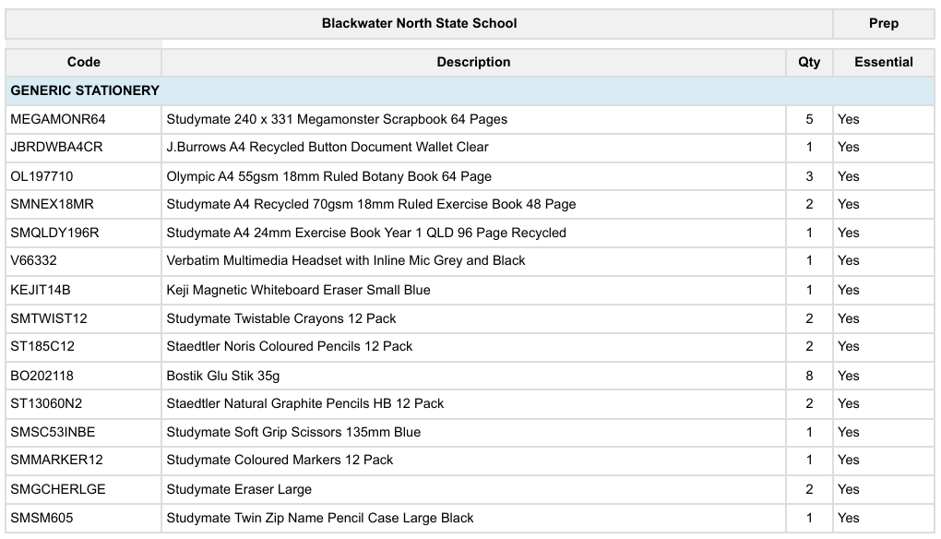
Write2Spell2Read – Book *Purchase through school office only* | 1 | $19.95

