Ghungalu Country (west of Rockhampton in central Queensland).

There are open grassy plains, mighty sandstone ranges (Blackdown Tablelands) and big rivers (McKenzie, Dawson and Comet rivers).

Ghungalu country is home to many people, animals, birds, reptiles and insects.
When there is drought the country dries to a gold yellow. When the rains come the country bursts into colour making the birds sing.

There are many tall wother (old) thullars (trees) in the moogera (bush) and on the mountains in Ghungalu country.

The big rivers that snake across the land are home to big whinners (fish). There is lots of bush tucker in the moogera.

There are animals like Wudar (kangaroo), walleroo and wallaby. There are big lizards like Goanna and Perentie. In the rivers whinner grow bigger. There are thummie (fat) thumboons (witchetty grubs) and sticky sugarbag from the gubba’s (bees) gootha (Hive) that Mook Mook loves to eat, sweet potatoes, bush plums and lots oranges, even the nectar from flowers.

Be careful in Ghungalu country, there are also animals to avoid like, dingo’s and scorpions, snakes of all kinds and spiders too. Is gets very hot in the summer so you need to drink lots of una (water) and the winters wind will give you a cold if you don’t stay warm.

Mook Mook lives in Ghungalu country – please scroll down for more information

http://www.mookmook.com.au/index.php?p=about
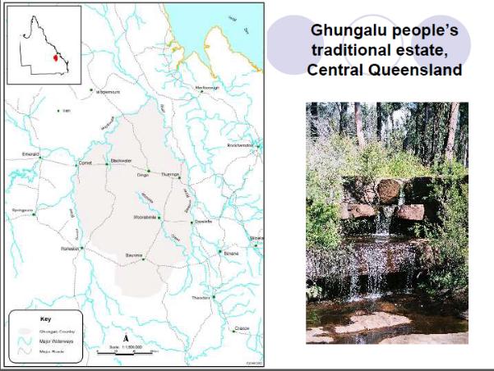

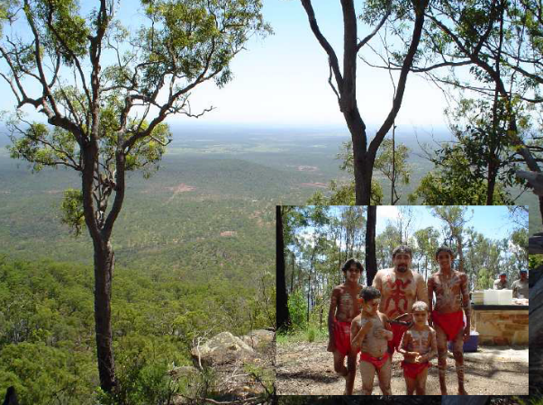
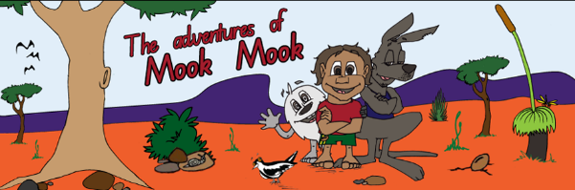

The Mook Mook series of Ghungalu children’s books is the work of author Marie Kemp and illustrator Jack Kemp.
Known to her family as Aunty Meen, Marie is also a senior Ghungalu woman, a poet, teacher, social worker and author. Her nephew, Jack, is a father and family man with a history in graffiti and a natural born talent to draw.
Mook Mook is a young Ghungalu boy who meets a little, hungry, hairy junjadee. They quickly become best friends exploring the moogera, meeting animals and learning life’s many lessons.

http://www.mookmook.com.au/

Pronouncing Ghungalu language
To create the right sounds when speaking Ghungalu language, place your tongue between your teeth when making T N and L sounds.
T will make a “th” sound
N will make “un” sound
L will make an “ull” sound

Ghungalu Words (36)

bulloo = grandfather | mittha-mitha = black | unagumoo =waterhole
bunghar = stick | moogera = scrub/bush | whambur = silly
dili = eye | mullar = arm | whambur whambur = silly thing
gootha = bee hive | murrar = hand | whinner = fish
gubba = native bee | ngaya = you | wother = old
gudtha = head | nghudar = dog | wudar = kangaroo
gummie = grandmother | oothung = sister | yabung = yes
gumoo = water | thullar = solid stick or tree | yubbu = father
gundoo = child | thumboon = witchetty grub | yinda = me
gunnyar = uncle | thummie = fat | yuckaddi = scared
gurrah = no | thungbul = hungry | yumber = home
gying gying = small girl | una = hole | yunghar = mother
http://www.mookmook.com.au/index.php?p=about

References:
Ghungalu and Duaringa Community proposed Cultural Centre
http://www.magsq.com.au/_dbase_upl/c-matter-10-maloney.pdf

Indigenous Language
http://www.abc.net.au/local/stories/2012/06/06/3519301.htm

